Name: Diya Shah

Topic: Windows Defender Antivirus Configuration and Threat Detection Practical

- Open Windows Security, navigate to Virus & Threat Protection, and perform a full system scan using Windows Defender. Take a screenshot of the scan summary once completed.
⇒ Click Start.
Open Windows Security.
Click Virus & threat protection.
Under Current threats, click Scan options. Select Full scan.
Click Scan now.
Wait until the scan completes.
Take a screenshot of the scan summary. Sample Result
Scan Type: Full Scan
Status: Scan Completed Successfully Threats Found: No threats detected Action Taken: None required

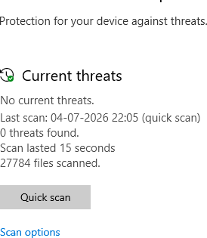

- Configure Windows Defender to enable real-time protection and set up a scheduled scan to run every Sunday at 8 AM. Write down the steps you followed.
⇒ Open Windows Security.
Select Virus & threat protection. Click Manage settings.
Turn Real-time protection ON.
Ensure Cloud-delivered protection is also ON

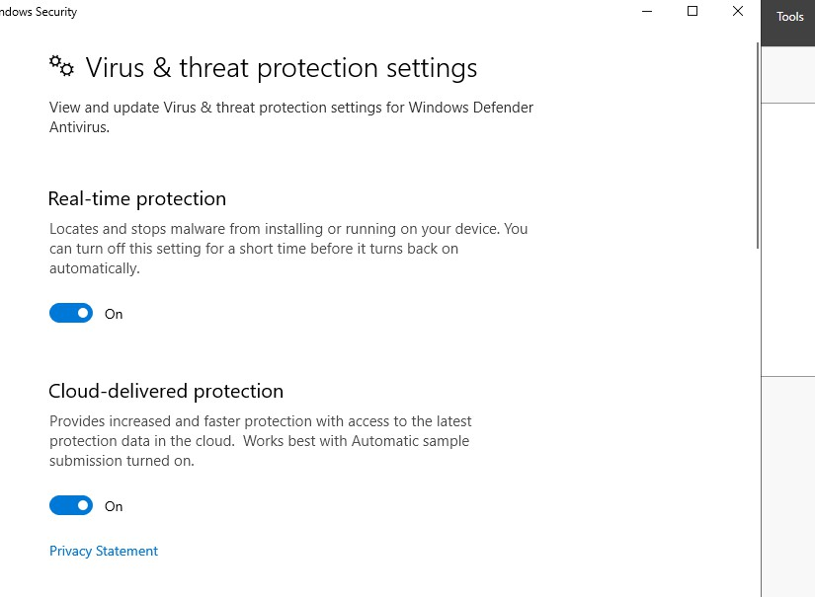
- Simulate downloading a harmless EICAR test file (from https://www.eicar.org/download-anti-malware-testfile/) and observe how Windows Defender reacts. Document the threat detected and the action taken by
Defender.<br><br><em><strong>Hint:</strong> The EICAR file is a safe industry-standard test for antivirus software.</em>
⇒ Press Win + R, type taskschd.msc, and press Enter.

Open Task Scheduler Library → Microsoft → Windows → Windows Defender.
Right-click Windows Defender Scheduled Scan. Select Properties.
Open the Triggers tab. Click New.
Set:
Begin the task: On a schedule Weekly
Sunday
Time: 8:00 AM
Click OK.
Click Apply and OK.

- Open Windows Defender settings and customize the notification options so that you only receive critical threat alerts. Test your configuration by triggering a Defender notification and describe the result.
⇒ Open Windows Security. Click Settings (gear icon).
Select Manage notifications. Disable unnecessary notifications.
Leave Critical Threat Notifications enabled. Save the settings.
Trigger a Defender notification (for example, by downloading the EICAR test file).
Result
Windows Defender displayed a notification only for the critical threat.
No unnecessary informational notifications were shown.
The critical alert informed that the EICAR test file was detected and quarantined.

- After completing a full scan, open the Protection History in
Windows Defender and list any threats detected, along with the actions taken (quarantined, removed, allowed). If no threats
were found, state 'No threats detected'.
⇒ Open Windows Security.
Click Virus & threat protection. Select Protection History.
Review the detected threats and actions taken. Sample Answer (If No Threats Found)
Threat Action
No threats detected No action required

Sample Answer (After Testing EICAR) Threat Action
EICAR Test File Quarantined
EICAR Test File Removed Automatically

